SIMATS ENGINEERING
SAVEETHA INSTITUTE OF MEDICAL AND TECHNICAL SCIENCES

Department | AIML
Course Code / Course Name | DSA0601 / Data Handling and Visualization
Experiment | Data Visualization using R
Name | A Shiva Shankar Reddy
Register Number | 192425174
Date | October 1, 20262026
Day | Thursday

SET 6: MONTHLY PRODUCT SALES
Dataset: Monthly Product Sales
List of Experiments Data Handling.pdf
Program 1: Grouped Bar Chart – Monthly Product Sales
Question
Create a grouped bar chart to compare the sales of different products across multiple months. Label the axes and title the chart.
Aim
To create a grouped bar chart to compare monthly sales of different products.
R Code
# Create monthly sales data
months <- c("Jan", "Feb", "Mar")

product_A <- c(2000, 2200, 2400)
product_B <- c(1500, 1800, 1600)
product_C <- c(1200, 1400, 1100)

# Combine data
sales <- rbind(product_A, product_B, product_C)

# Draw grouped bar chart
barplot(sales,
beside = TRUE,
names.arg = months,
col = c("blue", "green", "orange"),
xlab = "Months",
ylab = "Sales",
main = "Monthly Product Sales")

# Add legend
legend("topleft",
legend = c("Product A", "Product B", "Product C"),
fill = c("blue", "green", "orange"))
Output
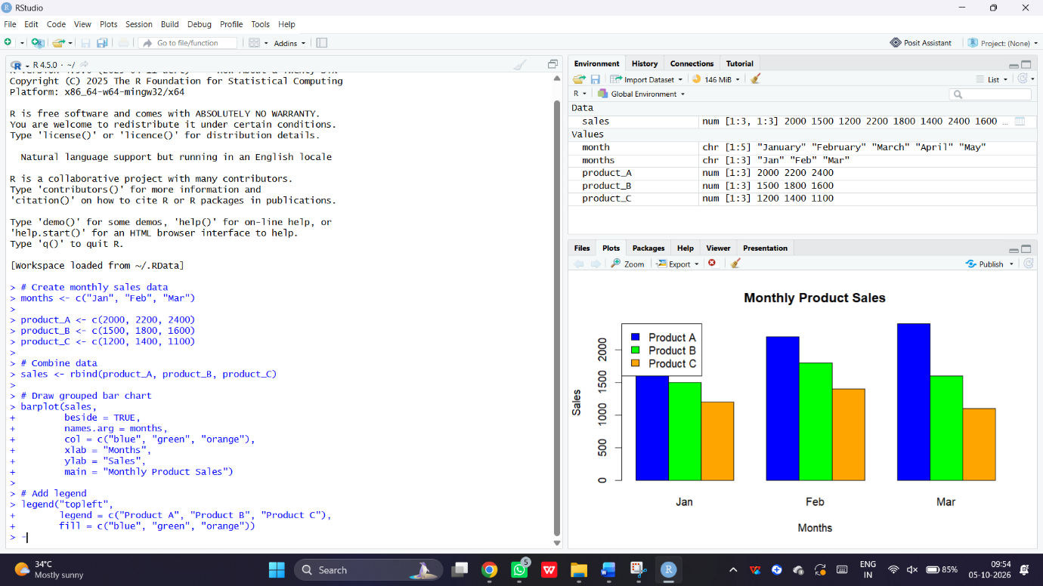
A grouped bar chart comparing the sales of Products A, B, and C across January, February, and March.
Result
The grouped bar chart was successfully created to compare monthly product sales.
Program 2: Stacked Area Chart – Sales Distribution
Question
Generate a stacked area chart to visualize the sales distribution of different products over time.
Aim
To visualize the contribution of different products to total sales using a stacked area chart.
R Code
# Create sales data
months <- 1:3

product_A <- c(2000, 2200, 2400)
product_B <- c(1500, 1800, 1600)
product_C <- c(1200, 1400, 1100)

# Combine data
sales <- rbind(product_A, product_B, product_C)

# Draw stacked area chart
matplot(months, t(sales),
type = "n",
xlab = "Months",
ylab = "Sales",
main = "Product Sales Distribution",
xaxt = "n")

# Add stacked areas
polygon(c(months, rev(months)),
c(product_A, rep(0, 3)),
col = "lightblue")

polygon(c(months, rev(months)),
c(product_A + product_B, rev(product_A)),
col = "lightgreen")

polygon(c(months, rev(months)),
c(product_A + product_B + product_C,
rev(product_A + product_B)),
col = "orange")

axis(1, at = 1:3, labels = c("Jan", "Feb", "Mar"))

legend("topleft",
legend = c("Product A", "Product B", "Product C"),
fill = c("lightblue", "lightgreen", "orange"))
Output
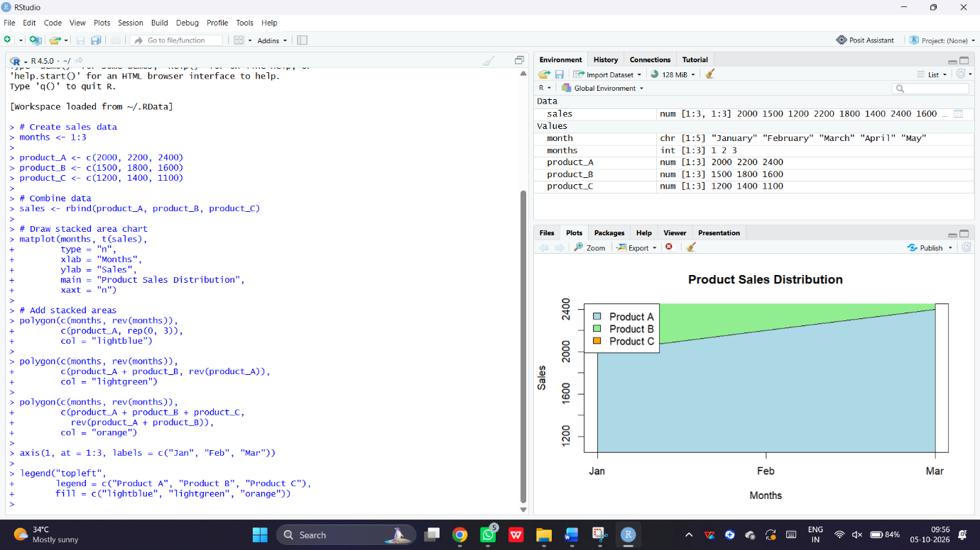
A stacked area chart showing the sales contribution of each product over three months.
Result
The stacked area chart was successfully generated to visualize monthly sales distribution.
Program 3: Sales Data Table
Question
Create a table to display the monthly sales data for each product. Label the columns and rows appropriately.
Aim
To create a table displaying monthly sales of different products.
R Code
# Create sales data
sales <- data.frame(
Month = c("January", "February", "March"),
Product_A = c(2000, 2200, 2400),
Product_B = c(1500, 1800, 1600),
Product_C = c(1200, 1400, 1100)
)

# Display table
print(sales)
Output
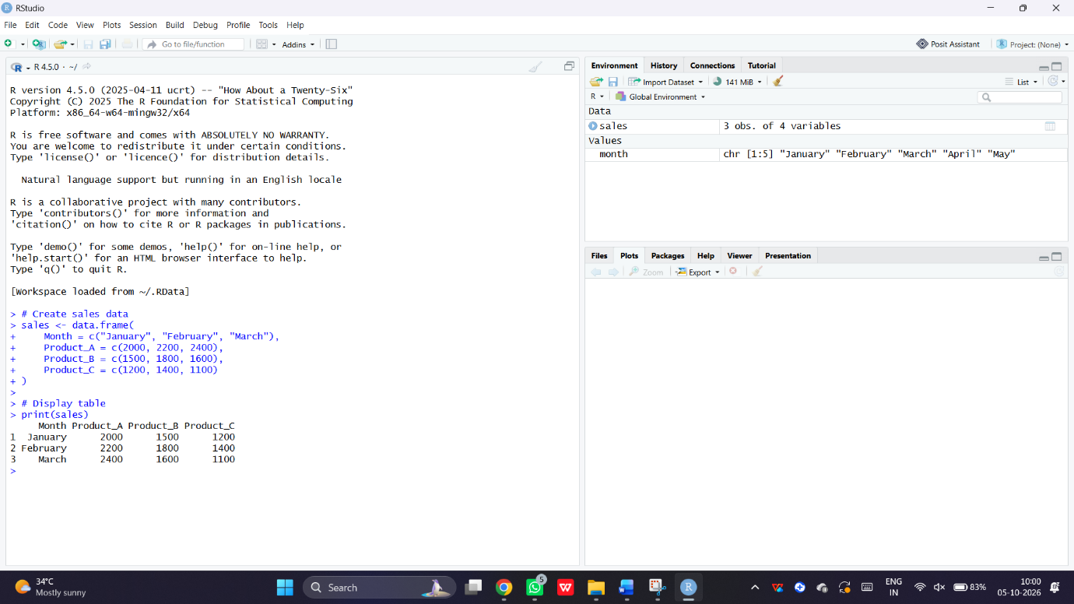
Month Product_A Product_B Product_C
1 January 2000 1500 1200
2 February 2200 1800 1400
3 March 2400 1600 1100
Result
The monthly sales data table was successfully created and displayed.
Program 4: Interactive Monthly Sales Dashboard
Question
Develop a Tableau dashboard with the grouped bar chart and stacked area chart to allow users to interact with the data.
Aim
To develop an interactive dashboard for exploring monthly product sales using R Shiny.
Note: This is an R Shiny equivalent of the requested dashboard, not a Tableau dashboard.
R Code
# Install package if required
# install.packages("shiny")

library(shiny)

# Create sales data
months <- c("Jan", "Feb", "Mar")

sales <- data.frame(
Month = months,
Product_A = c(2000, 2200, 2400),
Product_B = c(1500, 1800, 1600),
Product_C = c(1200, 1400, 1100)
)

# User interface
ui <- fluidPage(
titlePanel("Monthly Product Sales Dashboard"),

h3("Grouped Bar Chart"),
plotOutput("bar"),

h3("Stacked Area Chart"),
plotOutput("area")
)

# Server
server <- function(input, output) {

output$bar <- renderPlot({
data <- t(as.matrix(sales[, 2:4]))

barplot(data,
beside = TRUE,
names.arg = sales$Month,
col = c("blue", "green", "orange"),
xlab = "Month",
ylab = "Sales",
main = "Monthly Product Sales")

legend("topleft",
legend = c("Product A", "Product B", "Product C"),
fill = c("blue", "green", "orange"))
})

output$area <- renderPlot({
data <- t(as.matrix(sales[, 2:4]))

plot(1:3, type = "n",
ylim = c(0, 6000),
xaxt = "n",
xlab = "Month",
ylab = "Sales",
main = "Stacked Area Chart")

polygon(c(1:3, 3:1),
c(data[1, ], rep(0, 3)),
col = "lightblue")

polygon(c(1:3, 3:1),
c(data[1, ] + data[2, ], rev(data[1, ])),
col = "lightgreen")

polygon(c(1:3, 3:1),
c(colSums(data), rev(data[1, ] + data[2, ])),
col = "orange")

axis(1, at = 1:3, labels = months)
})
}

# Run dashboard
shinyApp(ui = ui, server = server)
Output
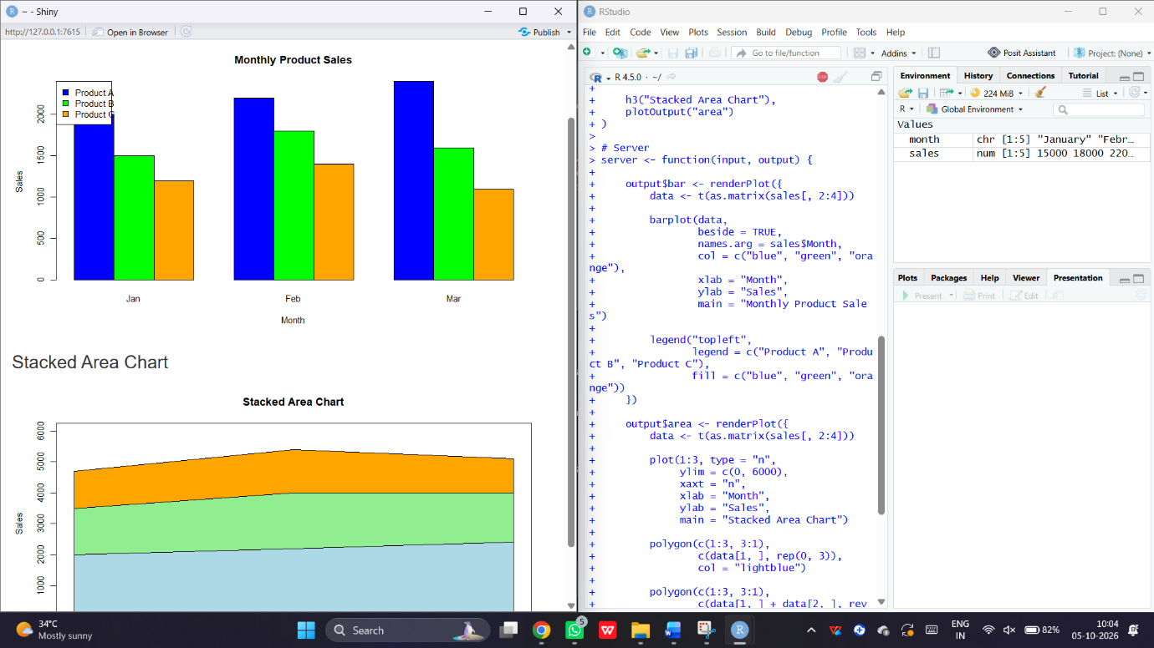
An interactive dashboard containing:
- Grouped bar chart comparing product sales.
- Stacked area chart showing the contribution of each product.
Result
The monthly product sales dashboard was successfully developed using R Shiny.

